Spearman rank correlation: USDCAD and EURGBP
Method 02 / daily log returns / Alpari D1 full available history

Study setup
Logical pair: USDCAD , EURGBP
Broker symbols: USDCAD_i , EURGBP_i
Snapshot: 2026-11-03_majors_alpari_D1
Timeframe: D1
Matched return window: 1999-01-06 to 2026-11-02 (UTC bar dates)
Matched return count n: 7185
Dropped unfinished last bar dated 2026-11-03 UTC after a tick-volume check against the prior complete day.
Complete matched rows (CSV): USDCAD-EURGBP_Spearman_D1.csv
Complete matched rows (HTML table): USDCAD-EURGBP_Spearman_D1_data.html

Method carried forward
Spearman rho is Pearson correlation on the ranks of matched daily log returns of close, ln(close_t / close_t-1), in the broker quote direction. Ties use average ranks. Quotes are not inverted. rho is symmetric under swap of the two symbols. rho = 0 means no consistent rank-order link in this sample; it does not mean no link of any kind. The score is not a cause, not a lead, and not a trading signal. Daily rows are not independent draws, so the two-sided p-value and approximate Fisher interval are reported and treated as secondary to rho. Same-sample Pearson r is shown only as a side check; a large rho minus r gap can flag outliers or a non-straight link.

Results
Spearman rho: -0.045060
Two-sided p-value: 0.000133062
Approximate 95% Fisher interval: [-0.068112, -0.021959]
Same-sample Pearson r: -0.014622
rho minus r: -0.030438

Conclusion
Over 7185 matched daily log-return rows for USDCAD and EURGBP (broker quote directions unchanged), Spearman rho is -0.0451 (negative, weak rank-order association in this sample). Approximate 95% Fisher interval: [-0.0681, -0.0220]. Same-sample Pearson r is -0.0146 (rho minus r = -0.0304). Two-sided p under the usual independent-ranks model is 0.0001331; that model does not match linked daily FX returns, so treat p as secondary. This does not establish cause, lead-lag, or a lasting trading rule.

Charts
Daily closes

Daily log returns
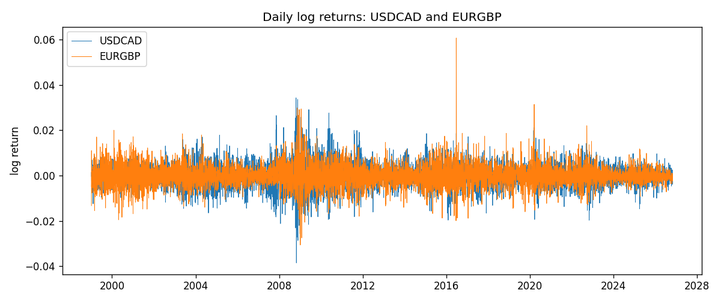
Log-return scatter
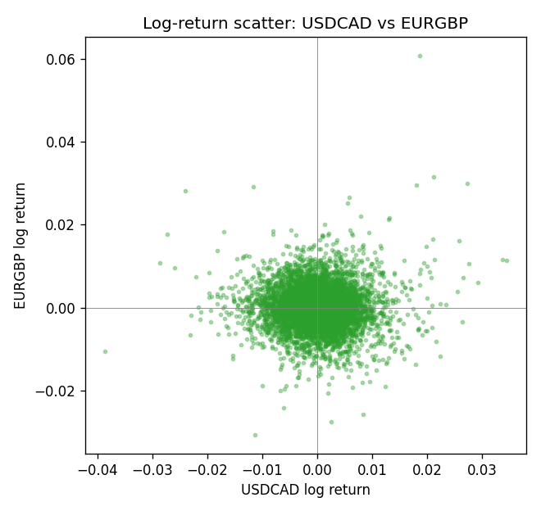
Rank-rank scatter
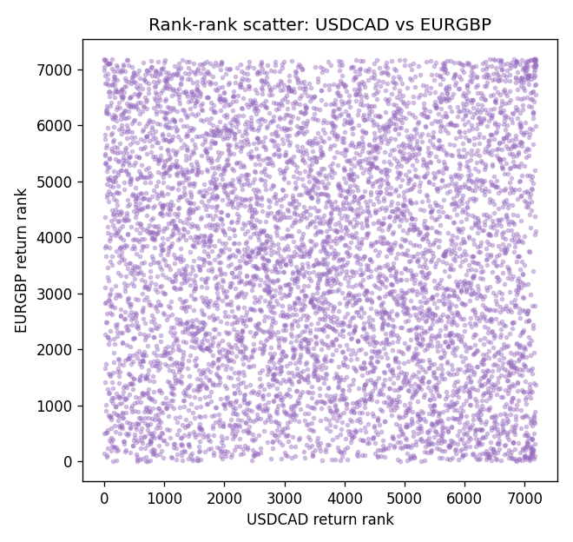

Data report
Every matched row that entered Spearman rho is stored in the sibling CSV named USDCAD-EURGBP_Spearman_D1.csv. That file is the complete data archive for redrawing charts. Embedding all rows as a Word table is impractical at this length; the Word file holds the column list, column summaries, and the first and last 15 matched rows.
Columns: time, USDCAD_open, EURGBP_open, USDCAD_high, EURGBP_high, USDCAD_low, EURGBP_low, USDCAD_close, EURGBP_close, USDCAD_tick_volume, EURGBP_tick_volume, USDCAD_spread, EURGBP_spread, USDCAD_real_volume, EURGBP_real_volume, USDCAD_log_return, EURGBP_log_return
Column summaries (matched calculation rows)
column | count | mean | std | min | 25% | 50% | 75% | max
USDCAD_open | 7185 | 1.2666594 | 0.16886861 | 0.9168 | 1.1183 | 1.29841 | 1.37203 | 1.6183
EURGBP_open | 7185 | 0.78693389 | 0.09666561 | 0.5734 | 0.6876 | 0.83387 | 0.86521 | 0.9769
USDCAD_high | 7185 | 1.2715589 | 0.16882635 | 0.9336 | 1.1227 | 1.30381 | 1.3764 | 1.619
EURGBP_high | 7185 | 0.79000929 | 0.09704455 | 0.5789 | 0.6896 | 0.8369 | 0.8681 | 0.9799
USDCAD_low | 7185 | 1.2621046 | 0.16891061 | 0.9056 | 1.11396 | 1.29347 | 1.36776 | 1.6102
EURGBP_low | 7185 | 0.78423344 | 0.09648411 | 0.5682 | 0.6855 | 0.83166 | 0.86287 | 0.9661
USDCAD_close | 7185 | 1.2666836 | 0.16885076 | 0.916 | 1.118 | 1.29833 | 1.3723 | 1.6137
EURGBP_close | 7185 | 0.78697576 | 0.09666885 | 0.5735 | 0.6878 | 0.83391 | 0.86533 | 0.977
USDCAD_tick_volume | 7185 | 81049.359 | 147325.09 | 37 | 5563 | 40946 | 71633 | 1410818
EURGBP_tick_volume | 7185 | 87109.869 | 145486.28 | 154 | 6553 | 44326 | 81375 | 1424684
USDCAD_spread | 7185 | 23.430202 | 18.259258 | 0 | 9 | 17 | 40 | 60
EURGBP_spread | 7185 | 21.335421 | 19.123862 | 0 | 4 | 13 | 40 | 50
USDCAD_real_volume | 7185 | 1.8384377e+10 | 9.670755e+10 | 0 | 0 | 0 | 0 | 2.5751613e+12
EURGBP_real_volume | 7185 | 2.7864528e+10 | 1.3519652e+11 | 0 | 0 | 0 | 0 | 3.5726265e+12
USDCAD_log_return | 7185 | -8.08e-06 | 0.00514591 | -0.03859748 | -0.00283484 | 5.597e-05 | 0.00272835 | 0.03436319
EURGBP_log_return | 7185 | 1.874e-05 | 0.00486681 | -0.03067367 | -0.00262366 | -0.00010035 | 0.00255918 | 0.06075387
First 15 matched rows (selected columns)
time | USDCAD_close | EURGBP_close | USDCAD_log_return | EURGBP_log_return | USDCAD_tick_volume | EURGBP_tick_volume
1999-01-06 | 1.5118 | 0.7019 | -0.0003306769 | -0.013303338 | 1803 | 2635
1999-01-07 | 1.5141 | 0.7097 | 0.0015202092 | 0.011051402 | 1568 | 2464
1999-01-08 | 1.511 | 0.7062 | -0.0020495197 | -0.004943862 | 914 | 3132
1999-01-11 | 1.5057 | 0.7053 | -0.0035137769 | -0.0012752393 | 953 | 2418
1999-01-12 | 1.5157 | 0.7077 | 0.0066194721 | 0.0033970309 | 1507 | 2670
1999-01-13 | 1.5226 | 0.708 | 0.0045420214 | 0.00042381861 | 2141 | 2612
1999-01-14 | 1.5332 | 0.7066 | 0.0069376546 | -0.0019793588 | 1816 | 2560
1999-01-15 | 1.5245 | 0.7012 | -0.0056905671 | -0.0076715819 | 1897 | 3031
1999-01-18 | 1.526 | 0.7017 | 0.00098344542 | 0.00071280921 | 1091 | 2461
1999-01-19 | 1.5302 | 0.7007 | 0.002748513 | -0.0014261269 | 1634 | 2606
1999-01-20 | 1.5211 | 0.7021 | -0.0059646885 | 0.0019960086 | 1499 | 2341
1999-01-21 | 1.5146 | 0.7016 | -0.0042823796 | -0.00071240297 | 2007 | 2450
1999-01-22 | 1.5184 | 0.7004 | 0.0025057712 | -0.0017118406 | 1713 | 2600
1999-01-25 | 1.5197 | 0.6966 | 0.00085579808 | -0.0054402425 | 1471 | 2304
1999-01-26 | 1.52 | 0.6962 | 0.0001973879 | -0.00057438255 | 1688 | 3025
Last 15 matched rows (selected columns)
time | USDCAD_close | EURGBP_close | USDCAD_log_return | EURGBP_log_return | USDCAD_tick_volume | EURGBP_tick_volume
2026-10-13 | 1.4214 | 0.84458 | -0.0046395653 | 0.00020130374 | 50947 | 30915
2026-10-14 | 1.42356 | 0.84553 | 0.0015184751 | 0.0011241873 | 56126 | 39105
2026-10-15 | 1.41843 | 0.84479 | -0.0036101503 | -0.00087557391 | 63096 | 45290
2026-10-16 | 1.41357 | 0.84307 | -0.0034322068 | -0.0020380844 | 54908 | 39309
2026-10-19 | 1.41091 | 0.84259 | -0.0018835331 | -0.00056950988 | 52155 | 38133
2026-10-20 | 1.40569 | 0.83957 | -0.0037066008 | -0.0035906254 | 54450 | 42542
2026-10-21 | 1.4045 | 0.83839 | -0.00084691787 | -0.00140647 | 51369 | 35843
2026-10-22 | 1.40081 | 0.83682 | -0.0026307268 | -0.0018743924 | 58806 | 44479
2026-10-23 | 1.40085 | 0.83751 | 2.85545e-05 | 0.00082421033 | 50387 | 37399
2026-10-26 | 1.40093 | 0.83762 | 5.7106554e-05 | 0.00013133309 | 49601 | 38735
2026-10-27 | 1.40449 | 0.83595 | 0.0025379458 | -0.0019957343 | 49541 | 36303
2026-10-28 | 1.39911 | 0.83651 | -0.0038379274 | 0.00066967224 | 56077 | 36532
2026-10-29 | 1.39895 | 0.83553 | -0.00011436495 | -0.0011722209 | 59551 | 49261
2026-10-30 | 1.39751 | 0.83351 | -0.0010298736 | -0.0024205543 | 59373 | 44060
2026-11-02 | 1.39837 | 0.83426 | 0.00061519094 | 0.00089940465 | 53578 | 43437

